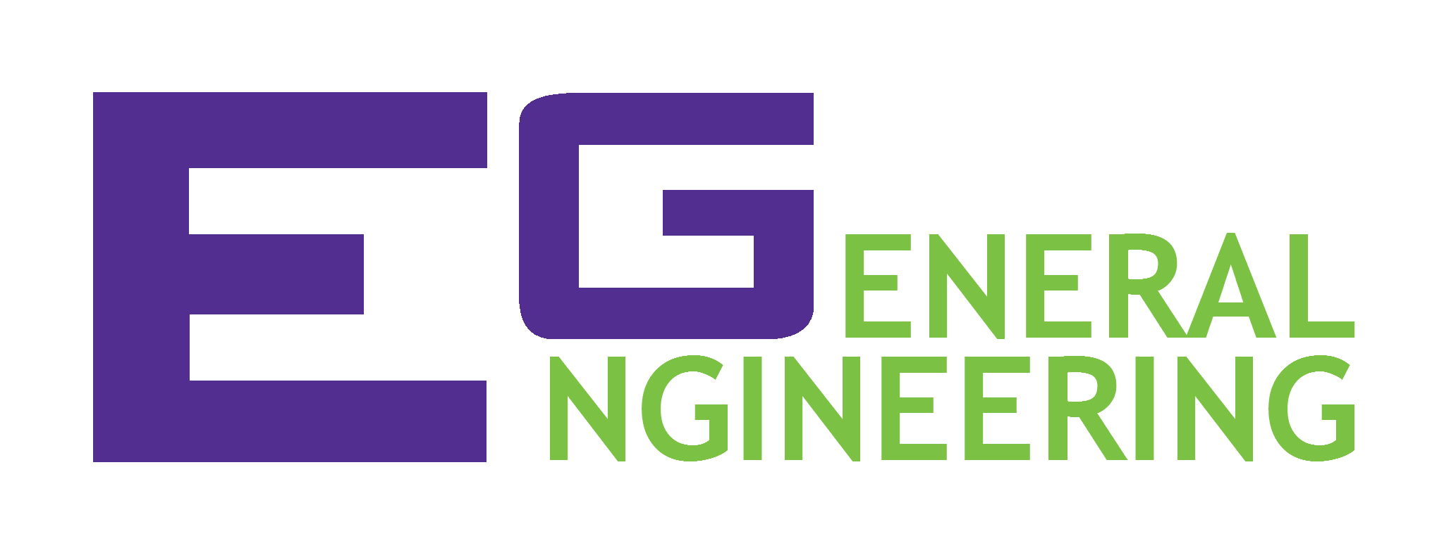
SLS Extra Credit: LEED Certification

Location and Transportation: | Pass | Fail
Diverse land use | □ | □
Disability access | □ | □
Bicycle and EV facilities | □ | □
Reduced parking footprint | □ | □
Sustainable Sites: | Pass | Fail
Open space | □ | □
Rainwater management | □ | □
Heat island reduction | □ | □
Light pollution reduction | □ | □
Water Efficiency: | Pass | Fail
Water quality management | □ | □
Water use reduction | □ | □
Water heating and cooling | □ | □
Advanced water metering | □ | □
Energy and Atmosphere: | Pass | Fail
Optimize energy performance | □ | □
Disability access | □ | □
Demand response | □ | □
Renewable energy production | □ | □
Indoor Environmental Quality: | Pass | Fail
Air quality management | □ | □
Interior lighting/daylight | □ | □
Thermal comfort | □ | □
Acoustic performance | □ | □
Innovation: | Pass | Fail
Connected building | □ | □
Intelligent inventory | □ | □
Security and safety | □ | □
Sustainability | □ | □

