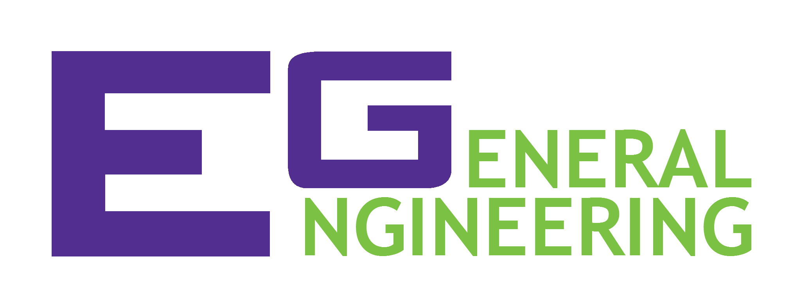 |  | COMMISSIONING STATEMENT Search & Recovery Robot
 | Project Name |  |  | Name
 | Company Name
 | Team Members |  |  | Section

TEST RESULTS:
 | Pass | Fail
Accepts the program. | □ | □
Footprint does not exceed 25cm x 25cm | □ | □
Main Task: (EC11) (5)
- Navigate to Zarya (Green) | □ | □
- Retrieve Zarya | □ | □
- Travel back to the starting point | □ | □
Extra Credit Route:
- Activate and traverse solar panel (EC13) (2) | □ | □
Extra Modules: (Check all that apply)
- Retrieve Unity (Yellow) (EC14) (2) | □ | □
- Retrieve Quest (Blue) (EC 15) (3) | □ | □
- Retrieve Pirs (Red) (EC16) (4) | □ | □
Acceptance Test has been successfully completed. The project’s development is concluded and the product is approved for commercial implementation.
Team Members |  | Date
Team Members |  | Date
Team Members |  | Date
Commissioned by |  | Date

