This is the style guide for all lab reports in Introduction to Engineering and Design (EG 1003). All lab reports in EG 1003 must use the style that is described in this guide. This style guide applies solely to lab reports in EG 1003. Other courses at the Tandon School of Engineering may use a different style guide so always ask professors if they have a preferred style for written material in their classes.
Lab reports should be written in a professional font. Times New Roman and Arial are preferred. A report can only use one font. EG 1003 does not require that equations written in Equation Editor be converted from the default font in Equation Editor (Cambria Math), to the font used throughout the rest of the report though converting that text is a best practice. The type size for all text, including labels and captions on illustrations, is 12 point. The text throughout a lab report must be double spaced.
All reports must be written in the passive voice. There may be rare instances where the use of a pronoun (e.g. she, he) is needed. In those instances, use the pronouns that are preferred by the individual being discussed. Where the preferred pronouns are not known, use they, them, their or use the individual’s name.
The Abstract, Procedure, and Data/Observations sections must be written in the past tense. The Introduction and Conclusion sections will be a mix of tenses, but where there is a discussion of what occurred in the lab, the past tense must be used. No part of any lab report may be written as if the lab exercise has not occurred. Where there is a discussion of something that is always true, such as the definition of a property, use the present tense.
The recommended word count for lab reports is 1,200 to 1,500 words though as the semester progresses, the reports become more complex and longer so the word count will necessarily increase. EG 1003 does not have minimum or maximum word or page counts for lab reports.
Lab reports should be written in Microsoft Word on a PC. Using any other application or using Word on an Apple computer will create formatting problems when the report is downloaded from eg.poly.edu.
What follows in this style guide is a discussion of how the reports should be organized and the material that belongs in each section. In addition to this guide, the Assignment section for every lab exercise should be reviewed and the responses to the questions or comments in that section must be included in the correct section of the lab report.

Title page
The Title page of the report must have the name and number of the lab exercise as written in the student manual, the course name and section number, the author’s name on a separate line from the lab partners, the full names of the lab partners, the lab date, and the report due date. The authors on team reports must be listed alphabetically from A to Z by last name on a single line.

Lab 12: Hot Air Balloon Competition
Introduction to Engineering and Design, Section Z5
Marie Curie
Lab partners: Ma Jun and Percy Julian
Lab date: 2/4/20
Due date: 2/11/20

Abstract
The Abstract is a brief summary of the report. It must have an objective, the major data from the lab exercise, and a conclusion.
For a competition lab, the major data and the conclusion are the competition ratios and rankings of the competitors. In those lab exercises where a device was designed and built physically and/or virtually, the Abstract must note how the device was designed and built (e.g. in LabVIEW or on an NI-ELVIS board), that it was tested, and that the test results were compared to the device’s specifications demonstrating that the device did or did not perform to specifications.
If any part of the lab exercise was not completed, the Abstract must note that and report if any significant part of the lab exercise was completed outside of lab hours.
Abstracts may not contain citations to any source listed in Works Cited, references to any illustration in the report, or the introduction of acronyms.
The Abstract must be written in the past tense.

Introduction
The Introduction must contain the background, formulas, ratios, equations, laws, principles, processes, specifications, and any other material the reader needs to know to understand the description of the exercise in the Procedure section, the data presented and discussed in Data/Observations, and the analysis of that data in the Conclusion section.
In a competition lab, the final paragraphs of the Introduction must be a discussion of the competition rules, a presentation of the competition ratio without data input, and a discussion of how the ratio, rules, and available materials influenced the design that was built. This design strategy discussion is required for all competition labs.
Pictures from the manual may be used in this section.
The Introduction will be a mix of tenses.

Procedure
The Procedure section must begin with a sentence that lists the materials used during the lab (e.g. “The materials used were…”).
The rest of the Procedure section is a description of the steps taken in the lab. This description must be sufficiently complete so that another person could follow the description and replicate the results. This section is presumed to be written in chronological order. Do not use language that indicates chronology (e.g. “next,” “then,” “First,” “Second,”).
Pictures of devices as they are being built or screenshots of programs as they are being coded should be used in this section to make the description of the lab exercise easier to understand. Tables that are partially completed can be used in this section to illustrate how a table was organized. Pictures of completed devices, completed tables, or screenshots of completed programs should be placed in Data/Observations.
Pictures of code or components of the exercise from the manual may be used in this section.
Where any part of the lab exercise was approved by the teaching assistants, that must be noted in the report (e.g. “The design was reviewed and approved.”)
The Procedure section must be written in the past tense.

Data/Observations
The Data/Observations section must contain all of the data that was produced during the lab exercise and a discussion of that data. Data includes tables showing any measurements made during the lab exercise, tables showing final results or competition results, pictures (e.g. top, front, side, isometric views) of completed devices, screenshots of completed programs or work performed virtually, or any calculations made during or after the lab exercise.
Hand drawn sketches may not be used in any section of the lab reports. Sketches should be rendered using Adobe Illustrator, which is available to students in NYU’s Virtual Computer Lab.
Illustrations must be accompanied by discussion that presents the data in the illustration in text form.
If a device was built virtually and/or physically in the lab, this section must explain how that device was tested. The test results can be presented in Data/Observations or in the Conclusion section. The test results must be compared to the specifications for the device to prove that the device did or did not operate correctly.
The Data/Observations section must be written in the past tense.

Conclusion
The Conclusion section must contain the analysis of the data that was presented in Data/Observations.
In a competition lab, this analysis must compare the performance of the competitors, as measured by the components of the ratio, to argue that one or more components of the ratio produced the competition results. For example, in a competition among hot air balloons that was judged by a ratio using time afloat, cost, and number of paperclips carried (payload), an analysis might conclude that the first-place balloon’s lower cost won it first place because the times afloat and payloads of all competitors were roughly the same.
For competitors that won second place or below, the Conclusion section in a competition lab must have a discussion of how a device would be altered to improve its standing in the competition. For example, in the same hot air balloon competition, an analysis might conclude that the second-place balloon might win first place if its volume was increased allowing it to carry a higher payload. In this discussion, the ratio would have to be re-calculated to show how much the payload would have to be increased and the extent to which any increase in cost resulting from additional materials purchased to achieve the higher volume would have to be overcome with a higher payload.
In a lab in which a device was designed and built physically and/or virtually, the test results must be presented in the Conclusion section if they were not presented in Data/Observations. The test results must be compared to the specifications for the device to prove that the device did or did not work according to its specifications.
This section can include comments on the lab exercise itself and the methods used.
The Conclusion will be a mix of tenses.

Works Cited
The Works Cited section is the bibliography or reference section of the report. The manual must be listed here. Reviewing sources other than the manual is encouraged. All sources that were relied on in the report must be listed in Works Cited and there must be in text citations to all sources listed in Works Cited. Any illustration taken from a source and not created in the lab must have a citation to that source in the caption.
EG 1003 uses author/date format for in text citations to a source. Citations to the manual, including in captions for illustrations taken from the manual, should use (NYU Tandon, 2019).

Original Data (Extra Credit)
Lab notes that were taken in lab are placed here. They can be found in the Lab Documents section on the EG website. Lab notes may not be used in any other section of a lab report and count for 1 extra credit point if placed at the end of the report. A caption is sufficient, no description is necessary. This concludes the end of the report.

The following sections provide further information on illustrations, tables, figures, and equations.

Illustrations
In EG 1003 reports, illustrations are typically tables, figures, and equations. This does not include hand-drawn figures! Figures include pictures, graphs, charts, and screenshots. All illustrations must be numbered and tables and figures must have a caption (e.g. “Figure 1: Hot Air Balloon Design,” “Table 1: Competition results.”). Equations are numbered, but do not have a caption (e.g. “(1),” “(2)”). Tables, figures, and equations are numbered consecutively and separately.
Captions must be brief and sufficiently descriptive so that the data in the illustration can be understood without reading the text. Captions may use title case, which capitalizes the first word in the caption and all important words, or sentence case, which capitalizes the first word in the caption and proper nouns. Captions may have a period at the end or not. One format should be used consistently throughout a report.
There must be an in text reference to every illustration in a lab report (e.g. “(Table 1)” “as shown in Figure 1.” “(1)” “Equation 1 shows…”). Where an equation is referenced in the text use the number (e.g. “(1)”), but when a sentence begins with a reference to an equation use “Equation” and its number (e.g. “Equation 1 shows…”).
Illustrations must be referenced individually. A report cannot refer to two or more illustrations in one reference (e.g. “The balloon design is shown in Figures 1 through 5).
An illustration should be centered on the page and directly below the first in text reference to that illustration. Do not wrap text around any illustration. The labels and captions for tables and figures should be placed flush with the left edge of the table or figure they identify and describe. The number for an equation should be in parentheses (e.g. “(1),” “(2)”) and should be flush right on the same line as the equation.

Tables
The teaching assistants in EG 1003 will collect data produced in each lab exercise and place it in tables or as scans in the Lab Documents section on eg.poly.edu. All tables in a lab report must use a single format so if the teaching assistants have used different formats for two or more tables and those tables will be used in a report, those tables must be converted to the same format. Tables can be created in Word at the Insert tab.
The labels and captions for tables belong above tables.
In competition labs, the results for the device that is the primary subject of the report must be highlighted in any table showing the competition results. Competitors must be ranked by their standing in the competition in any table showing the competition results. Table 1 is an example of a table in a report on the second-place hot air balloon.

Table 1: Hot Air Balloon Competition Results
Trial # | Cost ($) | Time Afloat (s) | Payload | Ratio | Highest | Rank
1 | $0.28 | 0.00 s | 2 | 0
2 | $0.28 | 1.23 s | 2 | 8.79 | 8.79 | 1
3 |  | -
1 | $0.48 | 0.00 s | 12 | 0
2 | $0.48 | 1.00 s | 3 | 6.25 | 6.25 | 2
3 |  | -
1 | $0.96 | 1.55 s | 3 | 4.84 | 4.84 | 3
2 |  | -
3 |  | -
1 | $0.18 | 0.00 s | 4 | 0 | 0 | 4
2 | $0.18 | 0.00 s | 2 | 0
3 | $0.18 | 0.00 s | 4 | 0
1 | $0.31 | 0.00 s | 8 | 0 | 0 | 4
2 |  | -
3 |  | -

Figures
The labels and captions for figures belong below figures (Figure 1).

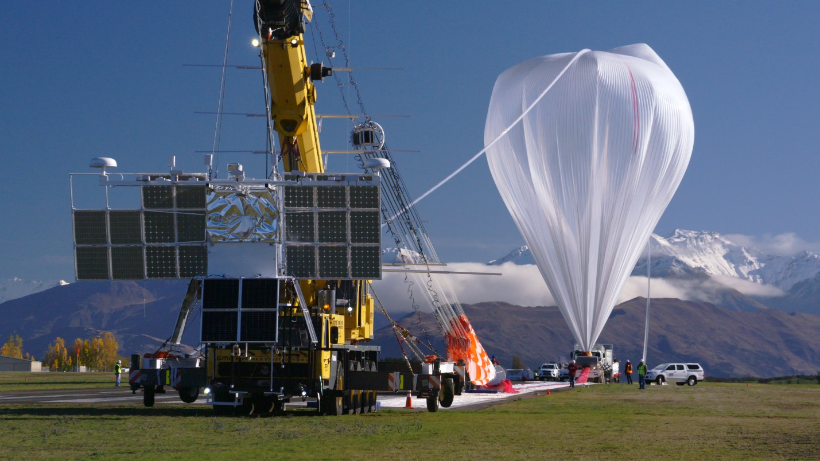
Figure 1: NASA Super-Pressure Balloon (NASA, 2017)

Equations
Equations must be written in Equation Editor (Insert > Equation) and the number that identifies the equation must be placed in parentheses flush right on the same line as the equation. The equation and its number must be on a separate line. The text below shows how an equation must be presented in a lab report:

The Ideal Gas Law (1) predicts that when a body of gas is heated, it will expand. With that expansion, its mass will remain the same, but its volume will increase and its density will decrease. Another body of gas with the same mass, but a lower temperature can have a much higher density.
(1)
$$\text{PV=nRT}$$
In (1), P is the gas pressure, V is the volume of gas, T is its absolute temperature, and n is the number of moles of gas. The universal gas constant R has a value of 0.0821 L · atm/mol · K (NYU Tandon, 2019).

Numbers and Symbols
The general rule in EG 1003 is that numbers above 10 must use the number and numbers below 10 must be spelled out. There are exceptions to this rule for titles, ratios, numbers using a decimal point, and fractions (e.g. “Lab 1,” “Table 1,” “Figure 1,” “0.5”). A number at the start of a sentence must always be spelled out.
Always use the number whenever a report discusses something that was measured (e.g. “5 cm,” “8 in,” “10 ml,” “75 °F”). The number must have units rendered with a standard symbol for the units. There must be a space between the number and the units except when reporting degrees of a plane angle (e.g. “A 90° turn to the right,” “It was 10° off the center line”).
Units are spelled out when they are not accompanied by a number (e.g. “Current was measured in milliamps,” “Temperature was measured in degrees Fahrenheit”).
Always place a zero before a decimal point and any numbers using a decimal point must be rounded to two places after the decimal point.

References
American Society for Engineering Education. 2020. “First-Year Programs Division Style Guide.” Washington, DC. ASEE
Institute of Electrical and Electronics Engineers. 2019 “IEEE Editorial Style Manual for Authors.” Piscataway, NJ. IEEE

