Lab 12: Hot Air Balloon Competition*
Introduction to Engineering and Design, Section Z5
Marie Curie
Lab partners: Percy Julian and Ma Jun
Lab date: 2/4/21
Due date: 2/11/21

Abstract
The objective of “Lab 12: Hot Air Balloon Competition” was to design and build a hot air balloon and enter it in a competition. The competition was judged by a ratio that used time afloat in seconds, the cost of the balloon in dollars, and the payload (paperclips) the balloon carried. The highest ratio won.
On its first trial, the balloon had a ratio of 0. On its second trial, the balloon had a ratio of 6.25. It placed second among five balloons in the competition.
The first-place balloon had a highest ratio of 8.79. The third-place balloon had a highest ratio of 4.84. The two remaining balloons tied for fourth with ratios of 0.
Introduction
While hot air balloons are primarily used for recreation and advertising, these lighter-than-air aircraft have uses in the sciences. The NASA Balloon Program uses zero-pressure balloons, which are open at the bottom and have ducts, for short flights and super-pressure balloons, which are enclosed and do not allow the gas inside them to escape, for longer flights. Super-pressure balloons (Figure 1) can lift up to 8,000 lbs of equipment to high altitudes to gather data on the atmosphere or Earth (NASA, 2017).
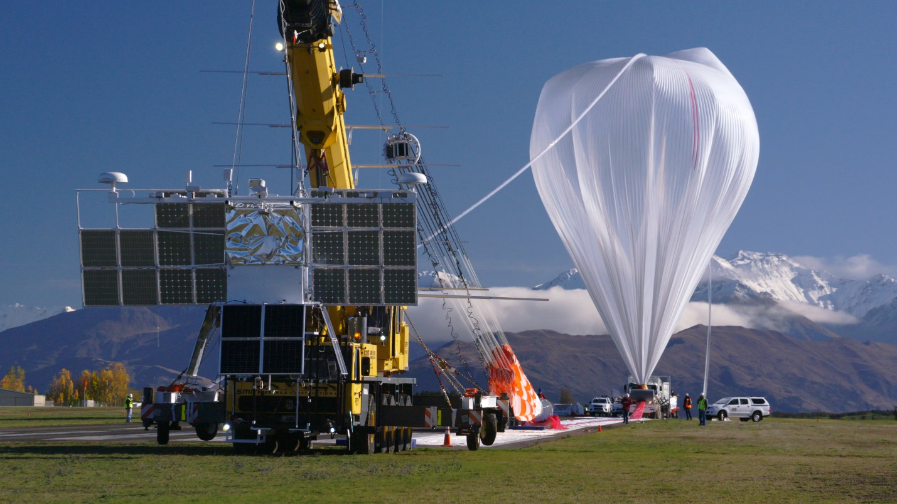
Figure 1: NASA Super-Pressure Balloon (NASA, 2017)
More common types of hot air balloons are dirigibles, blimps, and aerostats. Dirigibles have steel frames and use bags of light gas for lift. Blimps are large helium balloons with motors. Aerostats are blimps that are attached to the ground. Some aerostats are not attached to the ground and are used as weather stations or radar platforms. These aerostats can climb to 15,000 ft (NYU Tandon, 2021).
The Ideal Gas Law, gas density, and the Principle of Archimedes explain why hot air balloons float. The Ideal Gas Law (1) predicts that when a body of gas is heated, it will expand. With that expansion, its mass will remain the same, but its volume will increase and its density will decrease making it lighter. Another body of gas with the same mass, but a lower temperature can have a much higher density.
(1)
$$\text{PV=nRT}$$
In (1), P is the gas pressure, V is the volume of gas, T is its absolute temperature, and n is the number of moles of gas. The universal gas constant R has a value of 0.0821 L · atm/mol · K (NYU Tandon, 2021).
The Principle of Archimedes says that these differences in temperature and gas density lead to the tendency of masses of hot air and hot air balloons to rise. Archimedes’ principle says that when a body is immersed in a fluid, which can be a liquid or a gas, it displaces the fluid around it. As a result of that displacement, a force called buoyancy is exerted on the body that is equal to the weight of the displaced fluid (NYU Tandon, 2021).
When the air inside a hot air balloon is at the same temperature as the air surrounding the hot air balloon, that buoyant force is equal to the weight of air in the balloon. When the air in the balloon is hotter than the ambient air, the net upward force is greater than the weight of the air in the balloon. If the combined weight of the balloon’s structure and the air inside it is less than the buoyant force, the balloon will rise.
This lab was a competition. Balloons were designed and built using a number of available materials. Most of the materials had a cost (Table 1).

Table 1: Materials with Price List (NYU Tandon, 2020)
Material | Unit | Cost per unit ($)
Drawing paper | One sheet | $0.10
Tissue paper | One sheet | $0.10
8½ x 11 paper sheets | One sheet | $0.05
Kevlar string | 30 cm | $0.05
Adhesive tape | 30 cm | $0.03
Plastic straws | One straw | $0.00

Once constructed, the balloons were held over a heater to fill them with hot air. The designs were required to carry a payload of paperclips. Performance was judged by a ratio (2) that used time afloat in seconds, the cost of the materials used to build the balloon in dollars, and the payload or the number of paperclips carried (NYU Tandon, 2021).
(2)
$$\frac{\text{Time afloat} \left(\text{s}\right) }{\text{Cost (\$)}}\text{ x Payload}$$
The competition rules required that the design be approved before it was entered in the competition, the balloon’s volume could not exceed 1 m³, all materials used to build the balloon had to be purchased, no purchased materials could be returned for credit, time afloat was the elapsed time from when the balloon first rose to when it returned to its starting position, and if the balloon did not rise, time afloat was 0 s. All balloons were allowed three trials. Violating any rule resulted in disqualification though no balloons were disqualified in this competition (NYU Tandon, 2021).
That the rules had a maximum allowed volume was a hint that constructing a balloon with a volume as close to 1 m³ as possible was a winning strategy. A greater volume would result in a greater displacement of ambient air and a greater buoyant force pushing the balloon upward. That greater buoyant force would also mean that the balloon could carry a higher payload and since payload was the multiplier in the competition ratio that should result in a higher ratio. But cost was in the denominator so limiting that would also tend to increase the ratio.

Procedure
The materials used to design and build the hot air balloon were three sheets of tissue paper, one sheet of drawing paper, 30 cm of Kevlar string, and 30 cm of adhesive tape. Other materials used that had no cost were straws, a glue stick, a heater, scissors, and a stopwatch.
Ideas were discussed for a hot air balloon design and research on hot air balloons was conducted on the web. A design was agreed on and it was rendered using Adobe Illustrator (Figure 2). The design initially used a tissue paper bag and top for the balloon with a ring of drawing paper holding the bottom of the balloon open. That opening was reinforced with straws. The design was reviewed and approved.
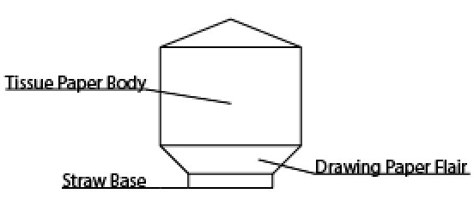
Figure 2: Sample Design for the Hot Air Balloon
Two sheets of tissue paper were laid out side by side on a lab table and both were folded in half on their length. Using the glue stick, glue was applied along one width of one sheet of tissue paper. That width was then pressed on the width of the second sheet of tissue paper so they overlapped by roughly 2.5 cm. The remaining widths of the now one sheet of tissue paper were glued together the same way forming a tube made of tissue paper.

The tube of tissue paper was held up and the diameter of the opening was measured. The remaining sheet of tissue paper was folded in half and two circles that had diameters that were larger than the opening were cut out using the scissors. Those two circles were glued together using the glue stick. The tube was held up and the circles were glued on one end of the tube (Figure 3).

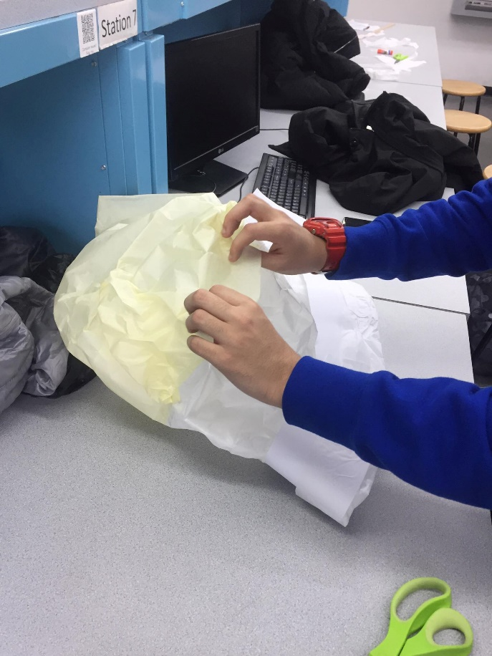
Figure 3: Balloon Top Being Applied
Using the scissors, the sheet of drawing paper was cut down its middle along its length to create two pieces of drawing paper that had the same width and length. The two pieces were glued together at their width with an overlap of 2.5 cm. The same was done at the other end of the now single strip of drawing paper forming a ring. The ring was glued to the opening of the balloon. Two straws were taped together to form a large plus sign. That plus sign was then taped into the balloon opening to keep the strip of drawing paper from closing (Figure 4).
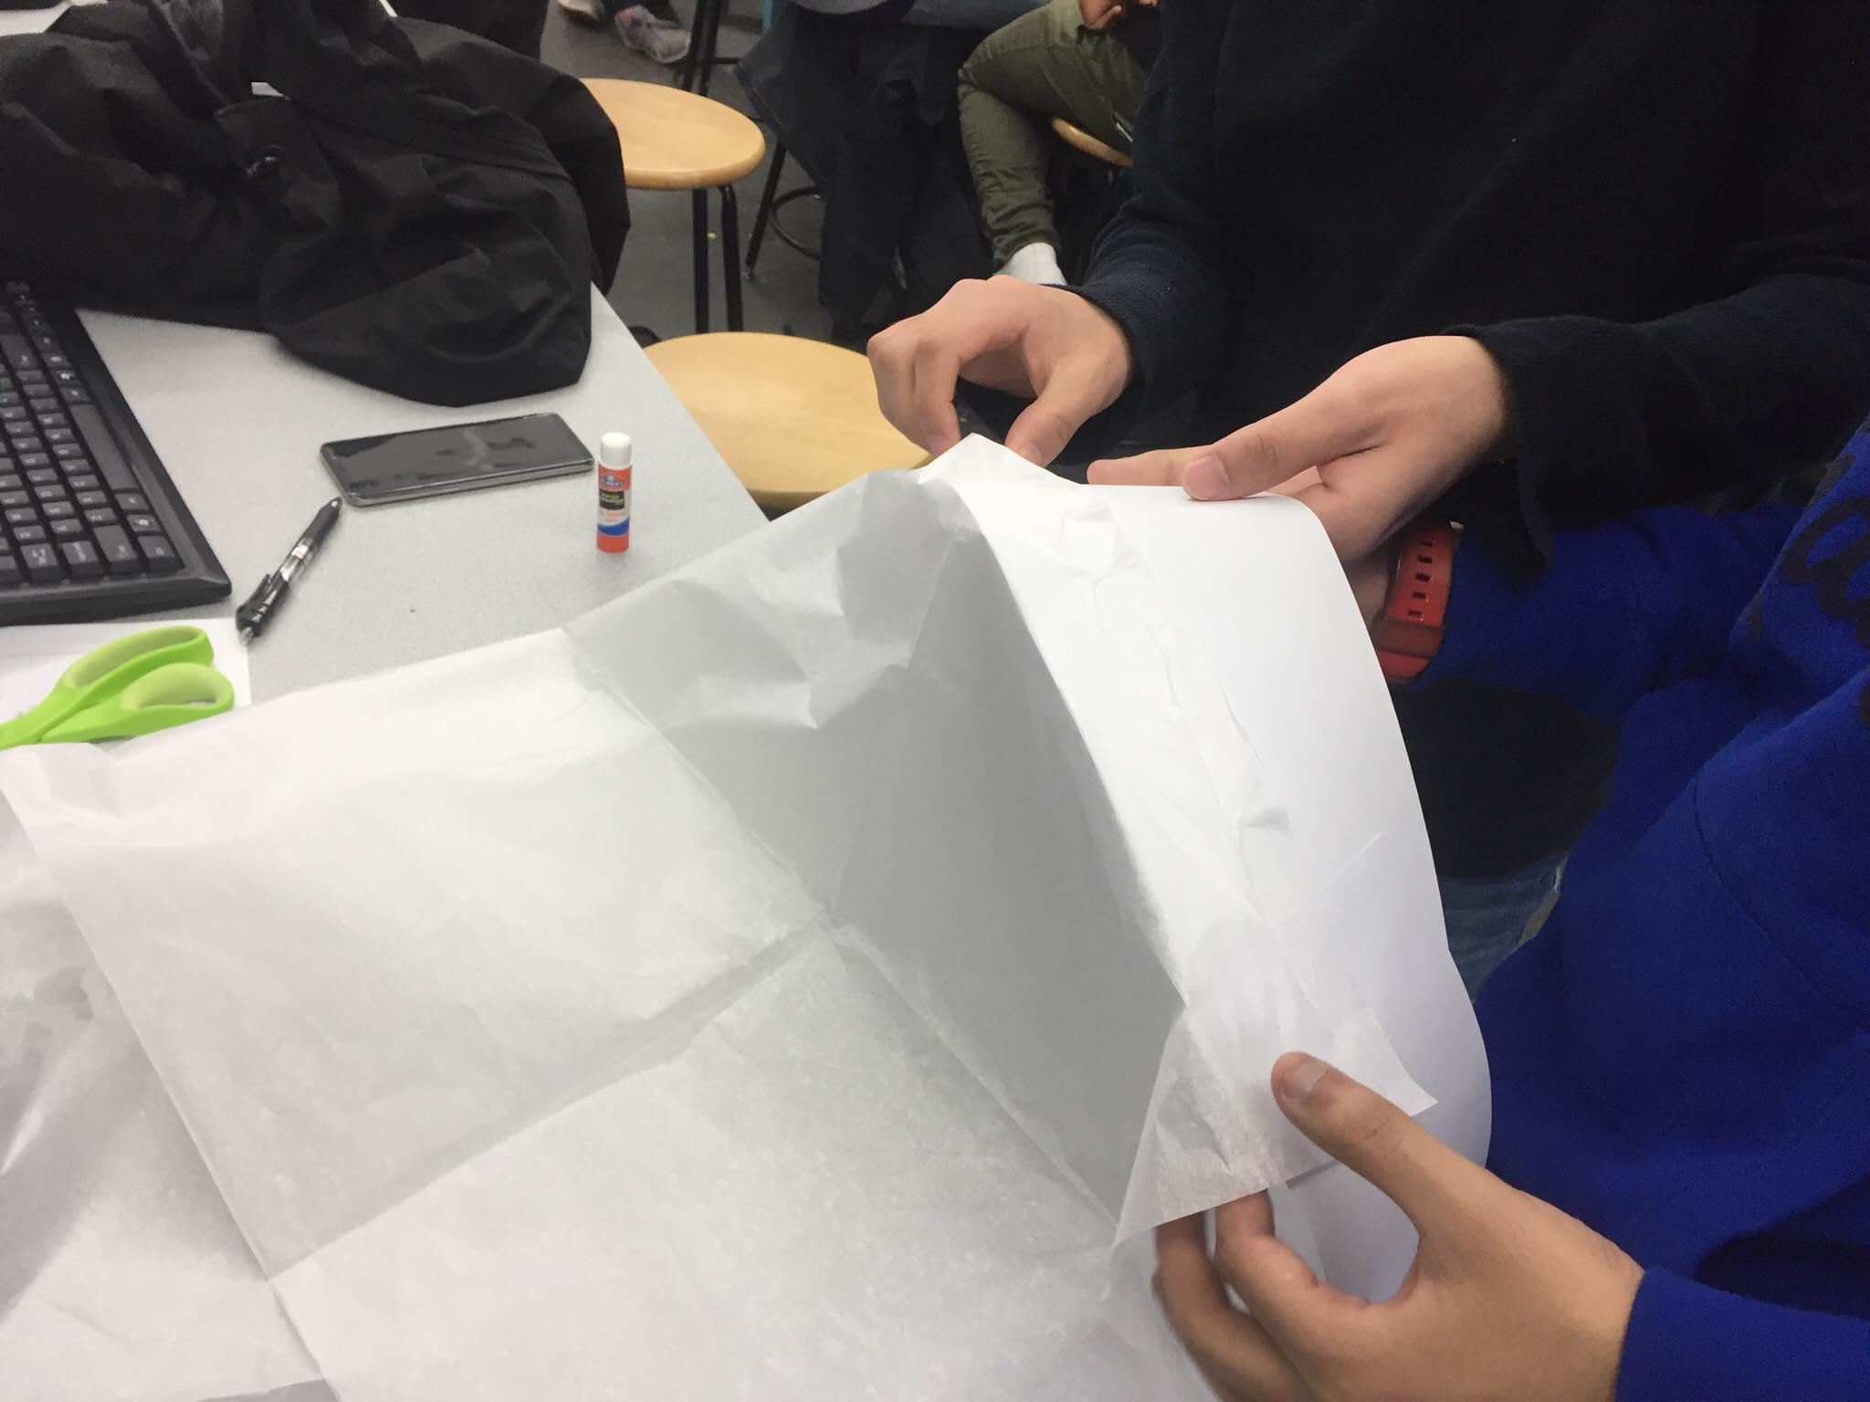
Figure 4: Hot Air Balloon Under Construction
The balloon was taken into the hallway and 12 paperclips were evenly placed on the strip of drawing paper. It was held over the heater until the balloon was filled with hot air and then it was released. The balloon fell to the floor immediately and had a time afloat of 0 s.
The balloon was returned to the lab. The drawing paper ring and the straws were removed from the design. A few holes that were detected when the original design was held over the heater were sealed with the glue stick. Three paperclips were attached to the new design and it was taken to the hall for a second trial. It was held over the heater and released once the balloon inflated.

Data/Observations
The hot air balloon placed second out of five balloons in the competition with a ratio (3) of 6.25.
(3)
$\frac{\text{1 s }}{\text{\$0.48}}\text{ x 3 = 6.25}$
Its volume was 0.48 m³. It had two trials and its cost was consistently $0.48 (Table 2).
Table 2: Cost of the Hot Air Balloon
Material | Unit | Cost per unit ($)
Drawing paper | One sheet | $0.10
Tissue paper | Three sheets | $0.30
Kevlar string | 30 cm | $0.05
Adhesive tape | 30 cm | $0.03
 | Total | $0.48

The second-place balloon had a ratio of 0 on its first trial because it had no time afloat. On its second trial, the balloon had a time afloat of 1 s with a payload of three paperclips. Its ratio on the second trial was 6.25 (Table 3).

Table 3: Hot Air Balloon Competition Results
Trial # | Cost ($) | Time Afloat (s) | Payload | Ratio | Highest | Rank
1 | $0.28 | 0.00 s | 2 | 0
2 | $0.28 | 1.23 s | 2 | 8.79 | 8.79 | 1
3 |  | -
1 | $0.48 | 0.00 s | 12 | 0
2 | $0.48 | 1.00 s | 3 | 6.25 | 6.25 | 2
3 |  | -
1 | $0.96 | 1.55 s | 3 | 4.84 | 4.84 | 3
2 |  | -
3 |  | -
1 | $0.18 | 0.00 s | 4 | 0 | 0 | 4
2 | $0.18 | 0.00 s | 2 | 0
3 | $0.18 | 0.00 s | 4 | 0
1 | $0.31 | 0.00 s | 8 | 0 | 0 | 4
2 |  | -
3 |  | -

The first-place balloon had a ratio of 8.79 on its best trial (Figure 5). Its volume was 0.60 m³. Its cost remained $0.28 over its two trials. It had a time afloat of 1.23 s on its second trial with a payload of two paperclips.
Figure 5: First-place Balloon
The third-place balloon had a single trial producing a ratio of 4.84 (Figure 6). Its volume was 0.50 m³. It had a payload of three paperclips with a time afloat of 1.55 s and a cost of $0.96.
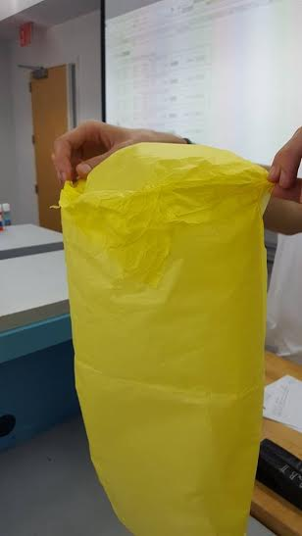
Figure 6: Third-place Balloon
The two remaining balloons had times afloat of 0 s on every trial and their ratios were 0.

Conclusion
The final design of the hot air balloon cost $0.48. One sheet of drawing paper, three sheets of tissue paper, 30 cm of Kevlar string, and 30 cm of adhesive tape were purchased to build the balloon though most of the adhesive tape and all of the Kevlar string were not used in the design. The drawing paper was used in the initial design, but discarded in the design that produced a time afloat (Figure 7).
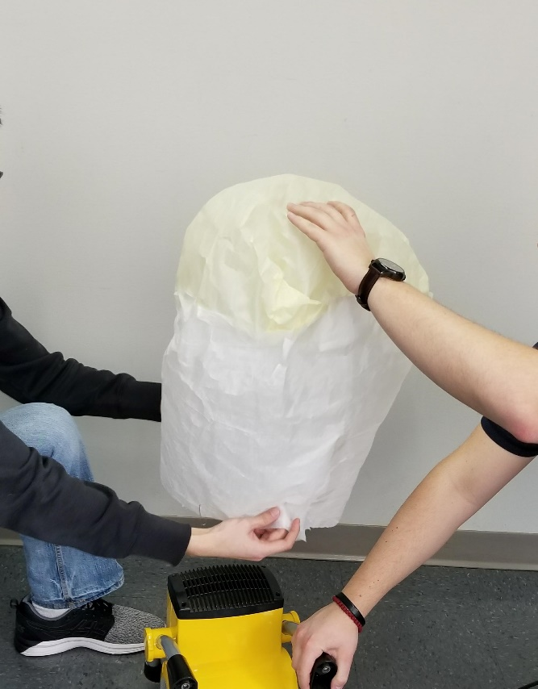
Figure 7: Hot Air Balloon, Final Design
Collectively, the items that were used in the initial design, but discarded in the design that produced a time afloat cost $0.18. Had those items not been purchased, the second-place balloon’s cost would have been $0.30. Assuming its time afloat and payload remained 1 s and three paperclips, respectively, its ratio would have been 10, putting it into first place.
At 1.23 s, the first-place balloon had a time afloat that was comparable to the time afloat for the second-place balloon. At two paperclips, the first-place balloon carried a smaller payload than the second- and third-place balloons, which carried three paperclips each. Its lower cost at $0.28 won first place.
The third-place balloon had a time afloat that was nearly double the times afloat of the first- and second-place balloons. It carried the same payload as the second-place balloon at three paperclips, but its higher cost at $0.96 guaranteed a third-place finish.
The original design strategy was to have a volume that was as close to 1 m³ as possible, but that was not achieved. The first- and third-place balloons had greater volumes though the difference in volume between the second- and third-place balloons was small at 0.02 m³. While the first-place balloon had the highest volume, the data show that its lowest cost among the three balloons that had a time afloat determined its rank in the competition. This shows that the other aspect of the original design strategy of limiting cost did not receive sufficient attention. The unused materials purchased for the second-place balloon accounted for 37% of the cost of that balloon.
It is possible that increasing the volume of the second-place balloon would increase its time afloat and payload carried, but the data indicate that would necessarily increase cost. That would present a substantial burden for a new balloon design to overcome when eliminating the cost of the unused items alone moves the second-place balloon into first place.
The balloons that did not achieve a time afloat are not considered here because those designs were not competitive. They must be redesigned.
Contribution Statement
In this lab, I was involved in the brainstorming and design portions. The teammates also each took turns using Adobe Illustrator. When making the physical balloon, I was the designated gluer, making sure all of the pieces were securely attached. After the first trial, I discovered the small holes in the original balloon and was able to repair them. My tasks were important to the overall experiment because I was involved in the brainstorm and design process and continued to contribute ideas to the group once we began building the balloon. This allowed the team to further improve our strategy and work off of each other’s ideas. Additionally, if I had not discovered the holes after our first trial, the balloon would not have floated and we would not have placed in second.

Works Cited
NYU Tandon School of Engineering. 2019. “Lab 12: Hot Air Balloon Competition.” Accessed 1 February 2020 from https://www.eg.manual.poly.edu
National Aeronautics and Space Administration. 2017. “Scientific Balloons.” Accessed 1 February 2020 from https://www.nasa.gov/scientificballoons

