What is a 3D printer? (Figure 1)

3D printing is a process of making 3 dimensional solid objects from a digital model, made from a CAD program (generally SolidWorks, or AutoCad). The 3D printing process involves adding successive layers of preheated materials on top of each other while maintaining the temperature of its surrounding in order for the materials to combine together. After the printing process is complete the object has to be cooled in order for it to solidify into the desirable shape.
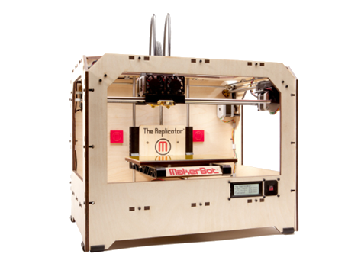
Figure 1; This Figure shows a picture of the Makerbot 3D printer used by EG for this Lab

What is SolidWorks?

SolidWorks is a Computer Aided Design program. Sometimes it is preferred over AutoCad because it excels at 3-D modeling. There is a wide variety of tools that that SolidWorks possesses that are used to alter the part and create almost anything. Another advantage of using Solidworks is its ability to create an assembly using previously made parts from SolidWorks. It should be noted that when a part is altered, the same part in the assembly is also changed, making editing dimensions much more efficient.

What is ReplicatorG?

ReplicatorG is a program used to load 3D designs from a STL format (Stereolithography format) to a DAE format (Digital Asset Exchange Format). By converting the STL format into DAE format, the file can now be processed by the 3D printer to print out the desired part.

The use of the 3D printer in Lab 7

In this lab, students will be designing a maglev cart that must navigate through the magnetic levitation track (For further details on the magnetic levitation lab refer to manual.eg.poly.edu). The materials you will be using to create this maglev cart will be LEGO parts. Due to the nature of LEGO bricks being sized by individual studs, it can be difficult to design a cart solely out of LEGO parts. In order to compensate for this, a part was designed from SolidWorks (Figure 2) so that it can be used as compatible part between the Magnetic Levitation Track and LEGO parts. Students will be responsible for determining the dimension x, most suitable for their design with a range between 1.5cm to 2.5cm. In order to provide students of the introductory course exposure to the capabilities and functionalities of the 3D printer a demonstration on how the printer is used will be given during the lab while students are designing their maglev carts.

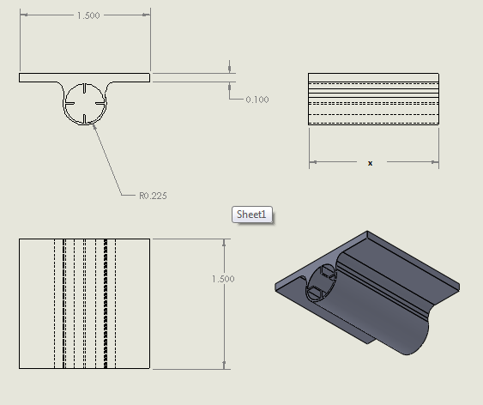

Figure 2; This is a drawing made using the SolidWorks program of the part designed, students will be responsible for determining the dimension ‘x’ they want to use for their maglev cart.

As part of this prelab assignment, please answer the questions on page 3 of this handout. This assignment will be collected and graded.

Assignment:

Briefly explain the process of the 3D printer.

How does SolidWorks play a role in 3D printing?

Why is the ReplicatorG necessary for the process of 3D printing?

How can the 3D printer be used for the Magnetic Levitation Competition Lab?

